**Functional Document**

|  |  |
| --- | --- |
| **Application** | NGERP – Centra |
| **Service Bundle** | Purchase Management |
| **Service Request** | NTA AP Invoice |

**Description:**

In **Compiere (NGERP - Centra),** the **NTA AP Invoice** screen manages invoices for Non-Trade Accounts Payable transactions.

**Workflow Process:**

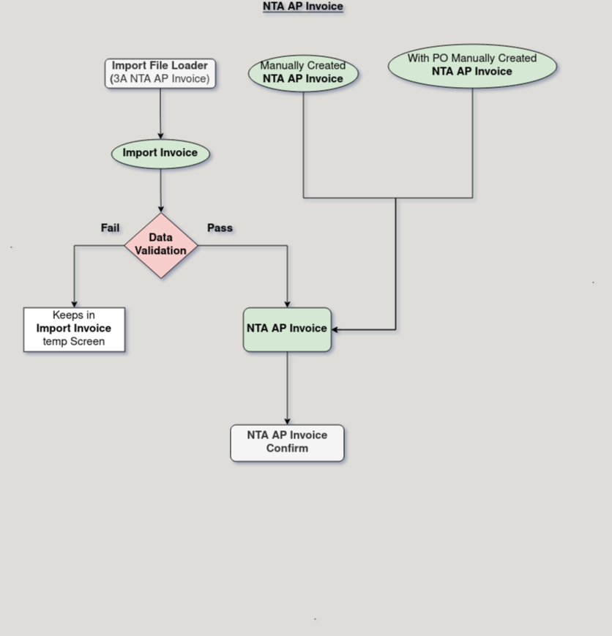

**Business Rules:**

* It is visible only in **HQ.**
* **Creation** is also possible in **HQ.**
* Form number limited to 11 characters.
* "With PO" enables auto-insertion of PO lines.
* Campaign date range must align with the invoice date.
* Invoice completion blocked if campaign dates do not match.
* VATInvoice type auto-fills the invoice type field.